**Lab Exercise 9– Creating Multiple EC2 Instances with foreach in Terraform**

Objective:Learn how to use foreach in Terraform to create multiple AWS EC2 instances with specific settings for each instance.

Prerequisites:

• Terraform installed on your machine.

• AWS CLI configured with the necessary credentials.

Steps:

1. Create a Terraform Directory: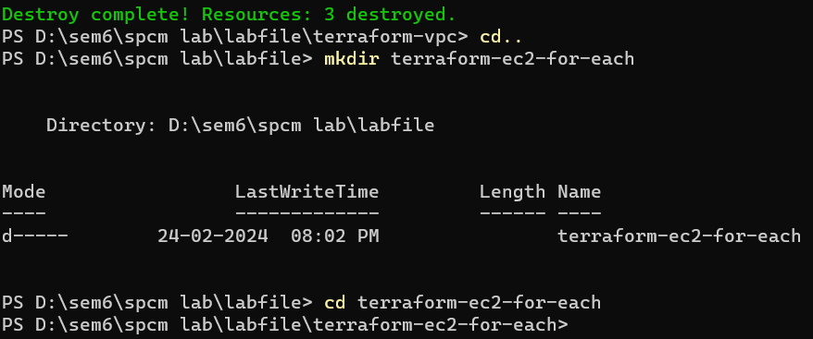

Create Terraform Configuration Files:

• Create a file named main.tf:

# main.tf

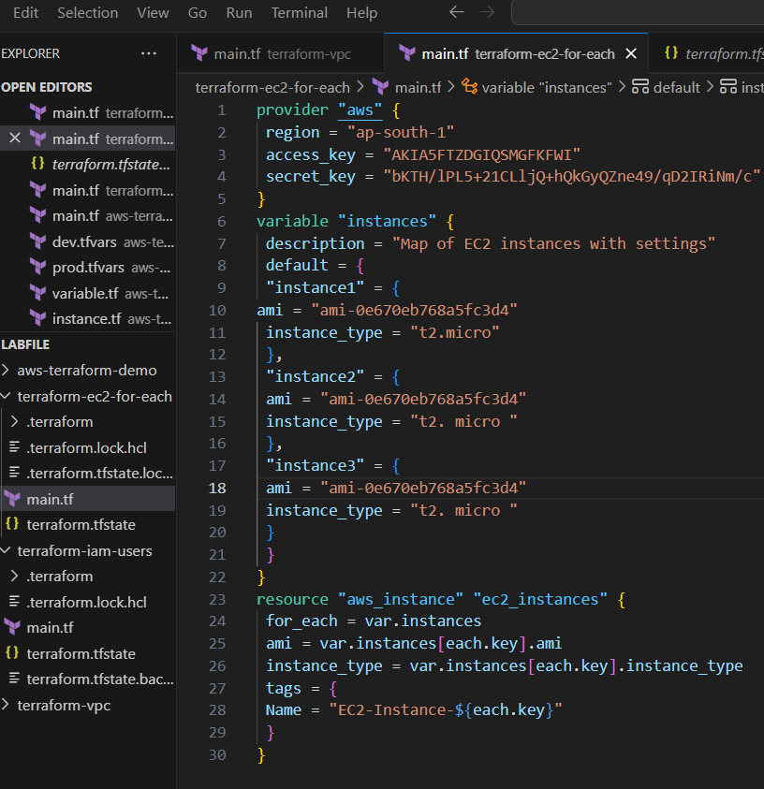

Initialize and Apply: Run the following Terraform commands to initialize and apply the configuration:

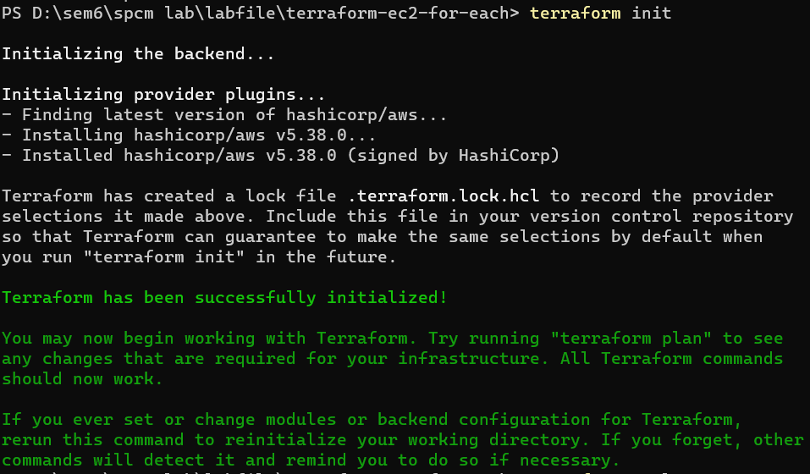

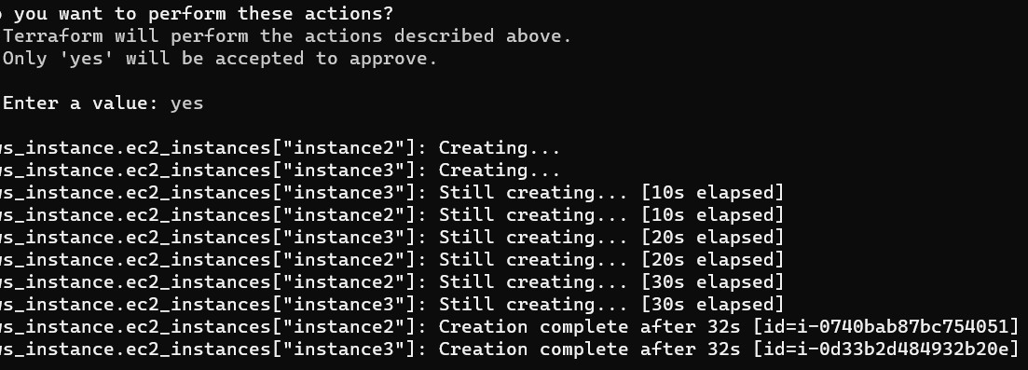

Verify Instances in AWS Console:

• Log in to the AWS Management Console and navigate to the EC2 service.

• Verify that the specified EC2 instances with the specified names and settings have been created.

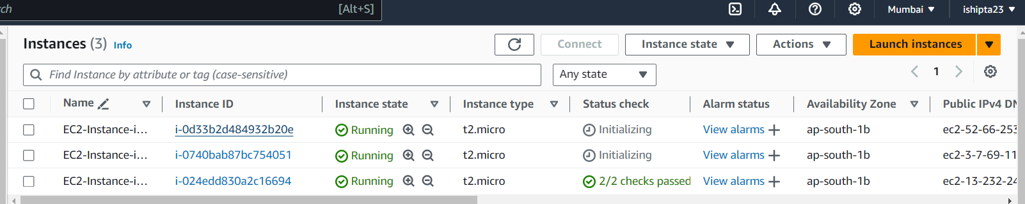

Clean Up: After testing, you can clean up the EC2 instances:

